

Cairo University

Egyptian Informatics Journal

[www.elsevier.com/locate/eij](http://www.elsevier.com/locate/eij) [www.sciencedirect.com](http://www.sciencedirect.com/science/journal/11108665)



FULL-LENGTH ARTICLE

ABC optimized RBF network for classification of EEG signal for epileptic seizure identification



Sandeep Kumar Satapathy a,*, Satchidananda Dehuri b, Alok Kumar Jagadev c

a *Department of Computer Science & Engineering, ITER, S’O’A University, Bhubaneswar 751030, Odisha, India*

b *Department of Information & Communication Technology, Fakir Mohan University, Vyasa Vihar, Januganj, Balasore 756019, India*

c *School of Computer Engineering, KIIT University, Bhubaneswar 751024, Odisha, India*

Received 18 December 2015; revised 28 March 2016; accepted 3 May 2016

Available online 9 July 2016

Abstract The brain signals usually generate certain electrical signals that can be recorded and ana- lyzed for detection in several brain disorder diseases. These small signals are expressly called as Electroencephalogram (EEG) signals. This research work analyzes the epileptic disorder in human brain through EEG signal analysis by integrating the best attributes of Artificial Bee Colony (ABC) and radial basis function networks (RBFNNs). We have used Discrete Wavelet Transform (DWT) technique for extraction of potential features from the signal. In our study, for classification of these signals, in this paper, the RBFNNs have been trained by a modified version of ABC algorithm. In the modified ABC, the onlooker bees are selected based on binary tournament unlike roulette wheel selection of ABC. Additionally, kernels such as Gaussian, Multi-quadric, and Inverse-multi-quadric are used for measuring the effectiveness of the method in numerous mixtures of healthy segments, seizure-free segments, and seizure segments. Our experimental outcomes confirm that RBFNN with inverse-multi-quadric kernel trained with modified ABC is significantly better than RBFNNs with other kernels trained by ABC and modified ABC.

© 2016 Production and hosting by Elsevier B.V. on behalf of Faculty of Computers and Information,

KEYWORDS

Electroencephalography; Radial basis function neural networks;

Artificial Bee Colony; Discrete Wavelet Transform

Cairo University. This is an open access article under the CC BY-NC-ND license ([http://creativecommons.](http://creativecommons.org/licenses/by-nc-nd/4.0/)

[org/licenses/by-nc-nd/4.0/](http://creativecommons.org/licenses/by-nc-nd/4.0/)).

1. Introduction

* Corresponding author.

E-mail addresses: [sandeepkumar04@gmail.com](mailto:sandeepkumar04@gmail.com) (S.K. Satapathy), [satchi.lapa@gmail.com](mailto:satchi.lapa@gmail.com) (S. Dehuri), [alokkumar_j@gmail.com](mailto:alokkumar_j@gmail.com) (A.K. Jagadev).

Peer review under responsibility of Faculty of Computers and Information, Cairo University.

**Production and hosting by Elsevier**

Electroencephalogram is a signal generated in human brain when there is an information flow among several neurons [1]. Human brain contains millions of neurons which are responsi- ble for information flow. Due to this flow of information a human body acts accordingly. A neuron hits another neuron and this process continues for several neurons, due to which a very small amount of electric discharge is generated. This electric signal is quite small in amount and hence it is very dif- ficult to measure the frequency. As a result, there are several electrodes placed on the scalp of those read this electric flow

<http://dx.doi.org/10.1016/j.eij.2016.05.001>

1110-8665 © 2016 Production and hosting by Elsevier B.V. on behalf of Faculty of Computers and Information, Cairo University. This is an open access article under the CC BY-NC-ND license (<http://creativecommons.org/licenses/by-nc-nd/4.0/>).

and frequency is recorded by a machine [2]. These signals are very transient in nature, because the frequency of these signals changes rapidly with respect to time. Therefore, the signal analysis [3] should be made carefully to analyze it properly. First of all, these signals must be recorded by some means before analyzing. There are 10–20 international standard for placement of electrodes on human scalp to record EEG sig- nals. The electrodes are placed on different regions of scalp, such as Frontal, Parietal, Occipital, and Temporal. Through these electrodes the EEG signals can be recorded and pro- cessed in a machine [4,5]. Generally, these machines will draw a graph of the recorded signal, which can be later analyzed by a medical professional. Secondly, the analysis of these signals is quite necessary for certain applications in medical science. Usually, Fast Fourier Transform is used for continuous signals which are not suitable for analysis of EEG signal. Discrete Wavelet Transform is one of the most efficient methods for analysis of these kinds of signals [6]. It is a signal decomposi- tion technique that uses two types of filters, low and high pass filter to divide the signal into low and high frequency bands. After this decomposition several features are extracted for each signal. This feature set can be used in further processing. After analyzing these signals we can discover valid and potentially useful information about human brain. In the sequel, this may help in identifying different types of human brain disorder diseases. Such a disease is known as Epilepsy [7]. It is a disor- der in human brain activity due to abnormal EEG signal flow. The time period of this disorder attack is called as epileptic sei- zure. This seizure may occur for a small period of time during which a very high frequency of EEG is generated. The visual examination is strenuous; hence, numerous studies are made for development of semi-automatic seizure detection tech- nique. Hence, the third and most important aspect of this research is the classification of EEG signal [8]. Classification is one of the fundamental tasks of data mining. It is a process of assigning an unlabeled pattern into a specific pre-defined class by constructing a model from the training patterns and subsequently validating in a test set. There can be two class or multi-class problem. For our study, we are going to classify the EEG signal into two groups that is either epileptic or normal [9–11]. Therefore, it is a two class problem. There are a lot of classification algorithms available, among which machine learning algorithms are most efficient and capable enough to classify data samples with high accuracy. Machine learning is a technique of constructing a model for doing a specific task by training the model with some previously known instances. This is just like a small kid learning different activities by observing the actions taking place near him. The different machine learning techniques used for classification are Artificial Neural Network [12–19], Support Vector Machine [2], and Radial Basis Function Neural Network [20], etc. All these techniques have their own applications in different areas. In [21] we have done an empirical analysis on application of these different machine learning techniques in classification of EEG signal for epileptic seizure identification. From this it has been concluded that SVM and PNN are very efficient. But the simplified architecture of RBF neural net- work grabs more attention for enhancing its accuracy in clas- sification of EEG signal [20,22,23]. Compared to other techniques RBFNN has a simple architecture consisting of a

single hidden layer along with input and output layers.

In this study, we have highly emphasized on the perfor- mance enhancement of RBFNN. For this, a novel algorithm for training RBFNN using Artificial Bee Colony (ABC) [20] has been proposed. Rest of the Sections in this paper is set out as follows. Section 2 describes about the materials and dif- ferent methods used to carry out this research work and the proposed algorithm for RBFNN training. Section 3 describes our proposed work. In Section 4, the experimental studies have been carried out with an analysis of the outcomes. Section 5 concludes the article with lots of research issues.

1. Materials and methods

Data selection and preparation is one of the key subsections of this section. The basic approaches such as RBFNNs and ABC are discussed in Sections 2.3 and 2.4, respectively.

* 1. *Data selection*

For this research work, we have collected EEG data for epilep- tic seizure identification from publically available online resource. This is an openly available source of data for EEG used by many researchers for their research work. It is mainly categorized into five types set A, B, C, D and E. Each set con- tains 100 single channel EEG segments. Each segment is of

23.6 s duration. All these data have been prepared by removing artifacts due to eye or muscle movements. Sets A and B have been collected from healthy patients having eyes open and closed respectively. Sets C, D, and E have been collected from epileptic patients, but C and D are recorded in seizure-free activity, whereas set E contains seizure activity.

* 1. *Discrete Wavelet Transform*

Basically, all types of signals are analyzed in time domain with their amplitudes. Signals such as EEG and ECG, are generally collection of amplitudes with respect to time. If we plot this data it can give a shape from which the pathological condition of a patient can be observed. If there is any significant devia- tion in shape it can be shown and observed properly by visu- alizing the graph. But sometimes it is necessary to get the frequency content of a signal for proper and accurate analysis of a signal. It can be done by using any transformation tech- nique such as Fourier Transform. But again the disadvantage of this is, it is not so effective for transient signals such as EEG as EEG signals have very uncertain and rapidly changing fre- quency. So, it is very difficult to analyze effectively. As a result, we need some other transformation technique such as Wavelet Transformation for analysis of EEG signals. This is just a new perspective for analysis and processing of data. The basic idea behind this technique is to use a scale for analysis. This wavelet transform can be divided into two categories such as Continu- ous Wavelet Transform (CWT), and Discrete Wavelet Trans- form (DWT). CWT was first developed as an alternative to Short Time Fourier Transform (STFT). Here, the product of the signal with a function that is wavelet function was calcu- lated. This transform was then calculated for different time domain. It is defined and is given as in Eq. (1):

Z ∞

*a*;*b*

CWT(*a*; *b*)=

∞

*x*(*t*)* u∇ (*t*)*dt* (1)

where *x*(*t*) represents the original signal. *a*, *b* represents the scaling factor and translation along the time axis respectively.

18) and eighteen for approximation coefficients. Several statistical features have been extracted. But for this study, four

The ∇ symbol denotes the complex conjugation and u∇

*a*;*b*

is cal-

important features were taken into considerations:

culated by scaling the wavelet at time *b* and scale *a* (as given in

Eq. (2)).

u (*t*)= 1 u *t* — *b* (2)

1. Maximum of wavelet coefficients in each sub-band.
2. Minimum of wavelet coefficients in each sub-band.
3. Mean of wavelet coefficients in each sub-band.

*a*;*b*

p|ﬃﬃ*a*ﬃﬃ|ﬃ *a*

1. Standard deviation of wavelet coefficients in each

where u

*a*;*b*

(*t*) represents the mother wavelet. In CWT, it is

sub-band.

assumed that the scaling and translation parameter *a* and *b*

change continuously. But the main disadvantage of CWT is, the calculation of wavelet coefficients for every possible scale can result in a large amount of data. It can be overcome by the help of DWT. It analyzes the signal at different frequency band by decomposing the signal into a set of high and low pass filters called as *approximation* and *detailed coefficients*. These coefficients can be calculated by using the wavelet toolbox available in MATLAB. Using the predefined functions avail- able inside this toolbox, we can easily extract the features of EEG signal. Some of the snapshots of wavelet GUI toolbox of MATLAB are given in Figs. 1–4. From the data available at [27], a rectangular window of length 256 discrete data was selected to form a single EEG segment. The wavelet coeffi- cients have been computed using Daubechies of order four. This technique was found to be more suitable because of its smoothing features which are more appropriate to detect changes in EEG signal. For our work, the original signal has been decomposed as four detailed coefficients (*d*1, *d*2, *d*3, *d*4) and four approximation coefficients (*a*1, *a*2, *a*3, *a*4). For sim- plicity, all the approximation coefficients are ignored except the one in the last step i.e. *a*4. Hence, the signal is decomposed into five segments by using DWT. In this work, for four detailed coefficients we get 247 coefficients (129 + 66 + 34 +

Therefore, for five coefficients all total twenty features have been extracted and the dataset has been constructed.

* 1. *Radial basis function neural networks*

RBFNN is one of the simplest form of Neural Network con- sisting of exactly three layers namely input, hidden, and output layer (as shown in Fig. 5). The restriction of only three layers makes it simplest and somehow efficient neural network archi- tecture. The idea of RBFNN has been derived from function approximation. An RBF network positions one or more RBF neurons in the space described by the predictor variables. This space has as many dimensions as there are predictor vari- ables. The Euclidean distance is computed from the point being evaluated to the center of each neuron. The radial basis function is so named because the radius distance is the argu- ment to the function. Output of RBFNNN depends on the dis- tance of the input from a given stored vector. For our work, *N* number of input neurons, *m* number of hidden neurons and one output neuron are taken. There are several kernel func- tions used in RBFNN, such as Gaussian, Multi-quadric, and Inverse Multi-quadric. Each of the functions has its own ben- efits depending on the data domain they are used in. Based on

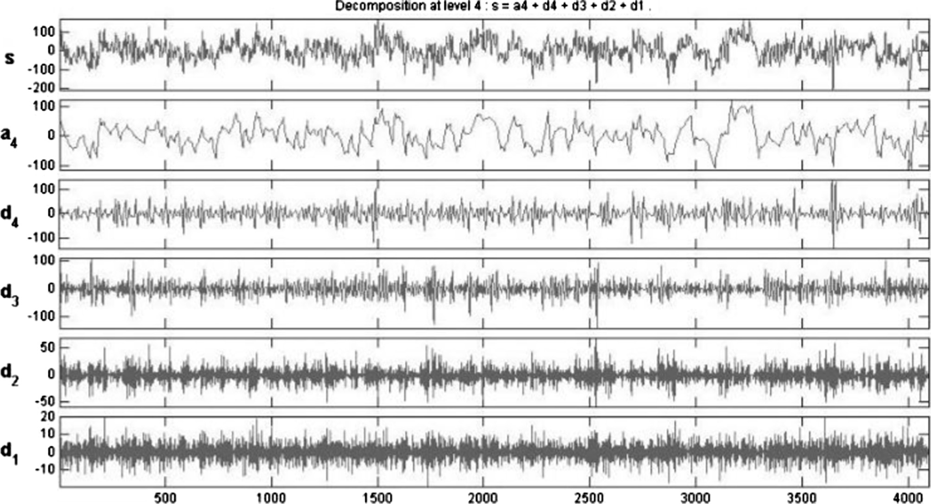

Figure 1 Single channel EEG signal decomposition of set A using db-2 up to level 4.

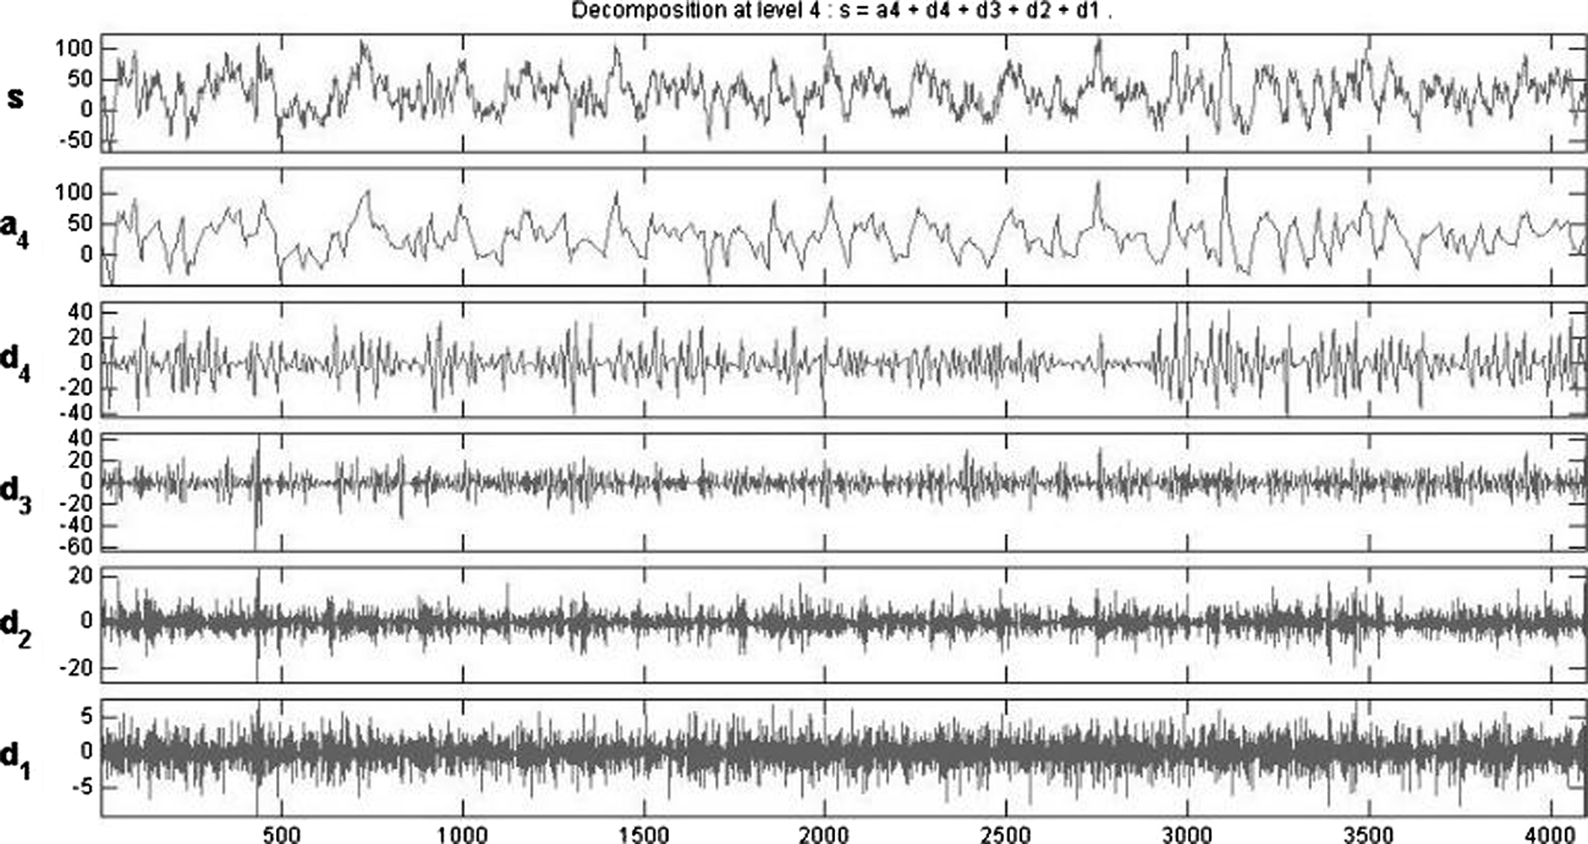

Figure 2 Single channel EEG signal decomposition of set D using db-2 up to level 4.

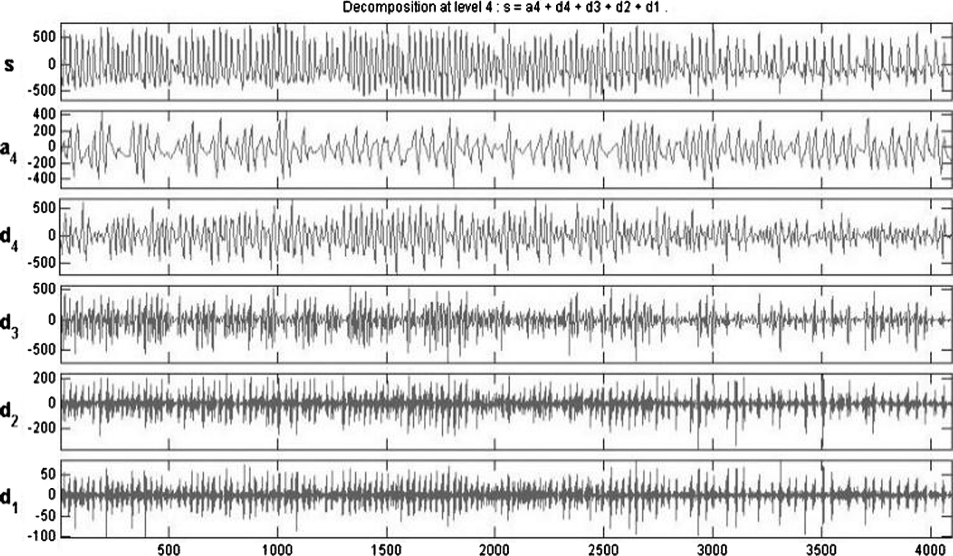

Figure 3 Single channel EEG signal decomposition of set E using db-2 up to level 4.

the recommendation of our previous research, we used to ver- ify the performance of Gaussian, Multi-quadric, Inverse Multi-quadric basis function in RBFNNs for identification

of epileptic seizure, but it was found that the performance of Inverse Multi-quadric is pretty higher than the performances of the other two.

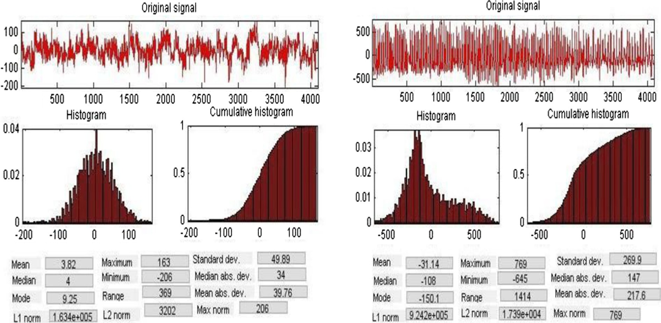

Figure 4 Statistical feature extraction from signals after decomposition.

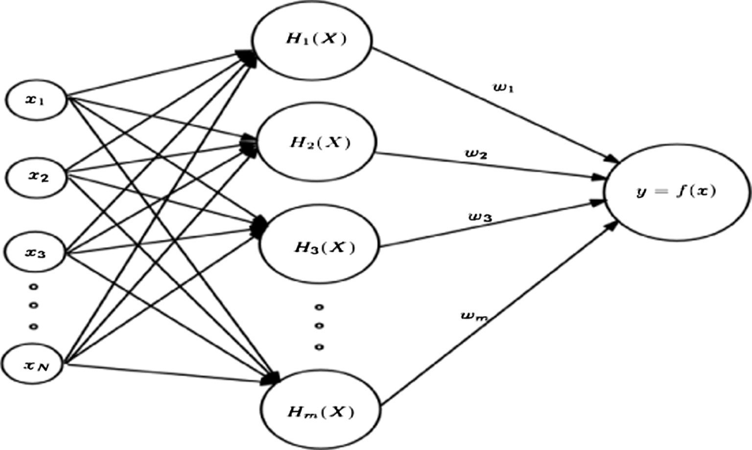

Figure 5 Architecture of RBFNNN.

The different symbols and dimensions used in the above fig- ure are as follows (as given in Table 1):

Table 1 Parameter description for RBFNNN.

Parameter

symbol

*N D*

Description

Dimension

Number of input vectors

Desired output vector

*M*

Number of hidden neurons

200 or 300

200 × 1 or

300 × 1

40

Input Vector (*X*)= {*x*1; *x*2; .. . *xN* } The above symbols can be further described as follows:

Hidden Neurons = {*H* 1(*X* ); *H* 2(*X* ); *H* 3(*X* ); ... *Hm*(*X* )}

Weight Vector (*W*)= {*w*1; *w*; .. . *wm*}

26 37

*C*11 *C*12 ··· *C*1*N C*21 *C*2*N*

6

.

|  |  |  |
| --- | --- | --- |
| *W* | Weight vector | 40x1 |
| *N* | Number of input neurons | 20 |
| *X* | Input vector | 1x20 |
| *C* | Center matrix | 40x20 |
| R | Spread vector | 40x1 |

Center Matrix (*C*)= .

4 .

. 75

*Cm*1 *Cm*2 ··· *CmN*

Spread Vector (r)= {r1; r2; .. . r*m*}

minimizing the error. The formula of gradient descent is given as follows (as shown in Eq. (9)):



*w* = *w* — g @*E* ; *c*

@*E*

= *c* — g

(9)

*i i* @*w*

*i*

*ij ij*

@*cij*

Figure 6 Working procedure of ABC algorithm.

Hence the output of RBFNNN can be defined as

*m*

RBF Output (*y*)= *wj* * *Hj*(*x*) (3)

X

*j*=1

where g is the learning parameter or step size. We have per- formed several experimental evaluations by considering differ- ent g values between 0.5 and 1.0. The detailed results are given in the next section. There are also several other learning tech- niques such as Particle Swarm Optimization (PSO) [24], Differ- ential Evolution (DE) [25], and Genetic Algorithm (GA) [26]. Basically, RBF networks are used in many applications because of its architectural simplicity and requirement of less number of adjustable parameters. Therefore, to employ the RBFNNN in the relevance of EEG classification, we require some supplementary techniques for improving its perfor- mance. This can be done by integrating optimization tech- niques with the training methods. There are several optimization techniques available such as PSO, ABC, and GA. Yet again, we opt for ABC optimization technique owing to its requirement for less number of adjustable parameters and its capability to produce global optimal solutions. In this study, we have proposed a new innovative training algorithm for RBFNN based Artificial Bee Colony (ABC) optimization algorithm. The different parameters such as center, spread and weight are trained by using ABC optimization algorithm. This is biologically inspired algorithm from the behavior of

where *Hj*(*x*) can be any one of the following: Gaussian Function; *Hj*(*x*)= exp



—*X* — *C*

r2

2

*j*

!

*j*

*j*

Multi-quadric function; *H* (*x*)= r ﬃﬃﬃ(ﬃﬃ*X*ﬃﬃﬃﬃﬃ—ﬃﬃﬃﬃﬃ*C*ﬃﬃﬃﬃ)ﬃﬃ2ﬃﬃﬃ+ﬃﬃﬃﬃﬃrﬃﬃ2ﬃﬃ ﬃﬃﬃ

(4)

(5)

artificial bees. It has been explained in the next section.

* 1. *Artificial Bee Colony algorithm*

Artificial Bee Colony (ABC) is a swarm intelligence technique

developed by Dervis Karaboga in the year of 2005. Its main

1

Inverse multi-quadric function; *Hj*(*x*)=

qﬃﬃﬃﬃﬃﬃﬃﬃﬃﬃﬃﬃﬃﬃﬃﬃﬃﬃﬃﬃ2ﬃﬃﬃﬃﬃﬃﬃﬃﬃﬃﬃﬃﬃﬃ

aim is to optimize numerical problems. It has been motivated from the foraging behavior of honeybees. The basic nature or

where; (*X* — *Cj*)

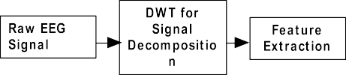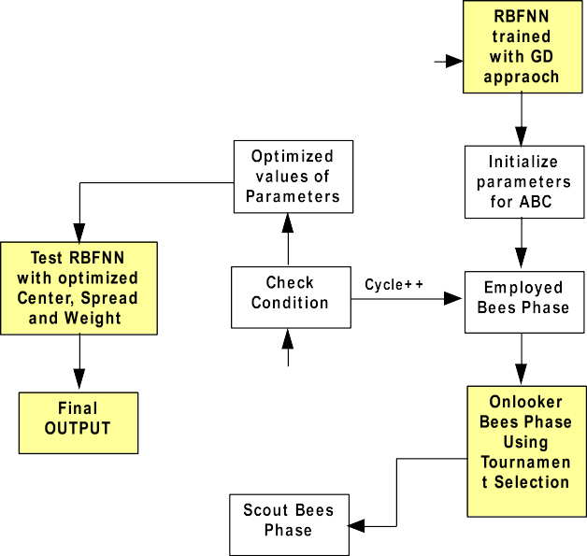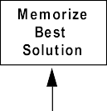

2

*N*

=—

X

*k*=1

(*xk* — *cjk*)

((*X* — *Cj*)

+ r2 )

(6)

2

(7)

intelligence of a honeybee can be used for solving many real life problems. Honeybees are one of the interesting swarms

To measure the performance of training algorithms, error is

calculated by finding the difference between desired output and actual output. Hence, the Mean Square Error Function can be defined as (given in Eq. (8)),

X

X

!

1 *n*

MSE(*c*; r; *w*)=

*n*

*i*=1

*dj* —

*m j*=1

2

*wj* * *Hj*(*x*)

(8)

*2.3.1. Learning of RBFNN*

Learning or training of a network is a process by which it adapts to the environment by adjusting few parameters. For RBFNN, to get the desired output for a given input there are mainly three adjustable parameters, such as Center, Spread, and Weight. There are several learning algorithms pro- posed by several researchers among which Gradient Descent approach is the most common. This is a first order derivative based optimization algorithm for finding local minimum of a function. According to Eq. (8), the error can be calculated by finding the difference between desired and actual output. Then the partial derivative of this error with respect to weight and center can be calculated to adjust the parameter with

Figure 7 Model of classification using RBFNNN with ABC algorithm.

in nature. They have the skills like photographic memories, space-age sensory, and navigation systems. Honeybees are social insects that live in colonies (as shown in Fig. 6).

In ABC algorithm there are mainly two types of bees, such as employed and unemployed bees. Unemployed bees can be again categorized as onlookers’ bees and scouts bees. The ini- tializations of food sources are done using the following formula:

*xmi* = *li* + *rand*(0; 1)* (*ui* — *li*) (10)

The employed bees search for a new food source having

more nectar within the neighborhood of the food source in their memory. The neighbor food sources can be selected by using the following formula (as shown in Eq. (11)):

*vmi* = *xmi* + u*mi*(*xmi* — *xki*) (11)

where *m* = number of solutions, *i, k* = number of parameters

to optimize, and u*mi* is a random number. After selecting the neighborhoods, their fitness can be calculated using a fitness function. The fitness value of a solution can be calculated as follows (as shown in Eq. (12)):

Employed bees, Onlooker bees, and Scout bees. To make the

signal comes with 5 different sets (A, B, C, D, and E). There- fore, the experimental work is divided into three parts. First is consisting of A & E, the second is set D & E, and the third is a collection of A & D with E. These datasets are now ready for the classification work.

Here, we have taken three prominent kernels (discussed in Section 2.3) for the nodes of the hidden layer of RBFNN. These three kernels play the pivotal role in addition to the novel training algorithms while classifying the EEG signals. By considering each individual kernel, RBFNN has been trained with Gradient descent approach and then successively trained with the ABC. Then these intermediate values of differ- ent parameters of RBFNN will be used to initialize the solu- tion vector for ABC algorithm. By using this algorithm, the optimal values of center, width, and weight will be calculated. Here the objective function is taken as the Mean Square Error as given in Eq. (8). With an objective of minimizing the error, ABC starts initializing the solutions (consists of three parame- ters, such as center, width, and weight) and then repeats the loop with required steps up to several runs/the limit, and the parameters will be optimized.

(12)

(( 1 ; if *fm*(→*x*

*m m*

→

*fit* (→*x* )=

1+*fm* ( *x*

*m*

)

*m*

) P 0

The ABC algorithm will proceed in three different phases,

1 + abs(*fm*(→*x m*)); if *fm*(→*x*

*m*) < 0

selection of onlooker bees easy and competitive, we replace

The bees which are waiting in the dancing area for taking decision on selecting a food source are called as onlooker bees. They select a food source depending on the probability of fit- ness values provided by employed bees according to the fol- lowing formula (as shown in Eq. (13)):

*fit* (→*x* )

the roulette wheel selection mechanism by binary tournament.

The inspiration of adopting this mechanism in ABC came from selection mechanism of genetic algorithms, in which ran- domly selected pair of bees will compete among each other to be selected depending on their fitness value. The detailed pseudo-code of proposed method is given below.

*P* = *i i*

(13)

*i* P*FS fit* (→*x* )

Pseudo code for proposed method

*Input: Preprocessed EEG dataset for epileptic seizure Identification.*

*Output: Class label prediction*

*Step1: Initialize and setup the parameters for RBFNNN Step2: Load the training sample for RBFNNN and train the network*

*Step3: Initialize and setup parameters for ABC algorithm with Gradient Descent learning approach up to certain number of iterations.*

*Step4: Initialize solution (Center, Width and Weight) for each food source in ABC algorithm to values of Center, width and weight values found in Step2.*

*Step5: Find the fitness value using Eq.* (12) *with the objective function defined in Eq.* (8).

*Step6: Set cycle=0 and for each employed bee set trials = 0 Step7: Repeat Step8 to 15 until cycle < cycleLimit*

*Step8: For each employed bee find the neighbor bee by using Eq.*

(11)

*Step9: Find the fitness value and make a greedy selection. Step10: If the solution is selected set trials = 0, Otherwise trial*

*++*

*Step11: Select an onlooker bee using tournament selection Step12: Find the fitness value and make a greedy selection. Step13: If the solution is selected set trials = 0, Otherwise trial*

*++*

*Step14: Memorize the best solution found so far Step15: If for any solution trials = trialLimit*

*Step16: Abandon the solution (Scout bee)*

*Step17: Randomly initialize the solution and go to Step7.*

*Step18: Set the RBF network by taking the optimized parameters (Center, Width and Weight) found in above steps.*

*Step19: Test the network with EEG test samples.*

*i*=1

*i*

*i*

Onlooker bees visit the food source that they select and

identify a nearby modified source. They evaluate and choose between the original and new source. The employed bees whose sources were abandoned become scouts and go in search of new food sources. The scout discovers a new food source by employing Eq. (11), where *rand* is a random number between 0 and 1. The algorithm avoids getting into local opti- mum by having the scouts perform a random global search for new food sources.

1. Our proposed method

Our study work, mainly focuses on classifying epileptic seizure patients vs. non-seizure patients by suitably trained RBFNNs. The trained RBFNN is developed by combining the best attri- butes of gradient descent trained RBFNN and modified ABC. Initially, we adopt gradient descent approach to train the RBFNN and then the trained parameters such as centers, spreads, weights, are feeding as the seed points of the ABC and modified ABC. The optimized parameters set up the final architecture of RBFNN to assign a class label to sample with no class label. The detailed flowchart of the proposed model is given in Fig. 7.

Once the raw EEG signal is collected from the source, it should first be analyzed to discover the hidden characteristics or features of these signals. This can be carried out using DWT technique, which decomposes the signal into several levels, thus extracts different statistical features. The EEG

1. Experimental study

For this study, five sets of EEG signals for Epileptic seizure identification have been collected from publicly available source [27]. There are three combinations of these sets taken for exper- imental study, that is set A & E (Experiment 1), set D & E (Experiment 2) and set A + D & E (Experiment 3). All these three datasets are first taken for classification using RBFNN with Gradient Descent Learning algorithm. This algorithm is evaluated by taking different values of learning parameter (g) from 0.5 to 1.0. By different experimental evaluation we found that for EEG dataset the Gaussian and Inverse-multi-quadric basis functions outperform as compared to Multi-quadric func- tion. After that a deep research has been done to enhance the performance of RBFNN using ABC algorithm.

* 1. *Environment and parameter setup*

For DWT of EEG signal we have used the MATLAB toolbox for wavelet transform. After this all other programming codes for entire experimental work have been designed using Java platform (JDK 1.8 with Eclipse Luna IDE). For ABC algo- rithm there are several parameters that have been set initially as given below:

* + 1. Colony size = 40 (that is number of employed bees + onlooker bees)
    2. No. of food sources = 20 (colony size/2)
    3. maxLimit = 100 (number of times a food source can be improved)
    4. maxCycle = 50 (number of cycles for foraging)

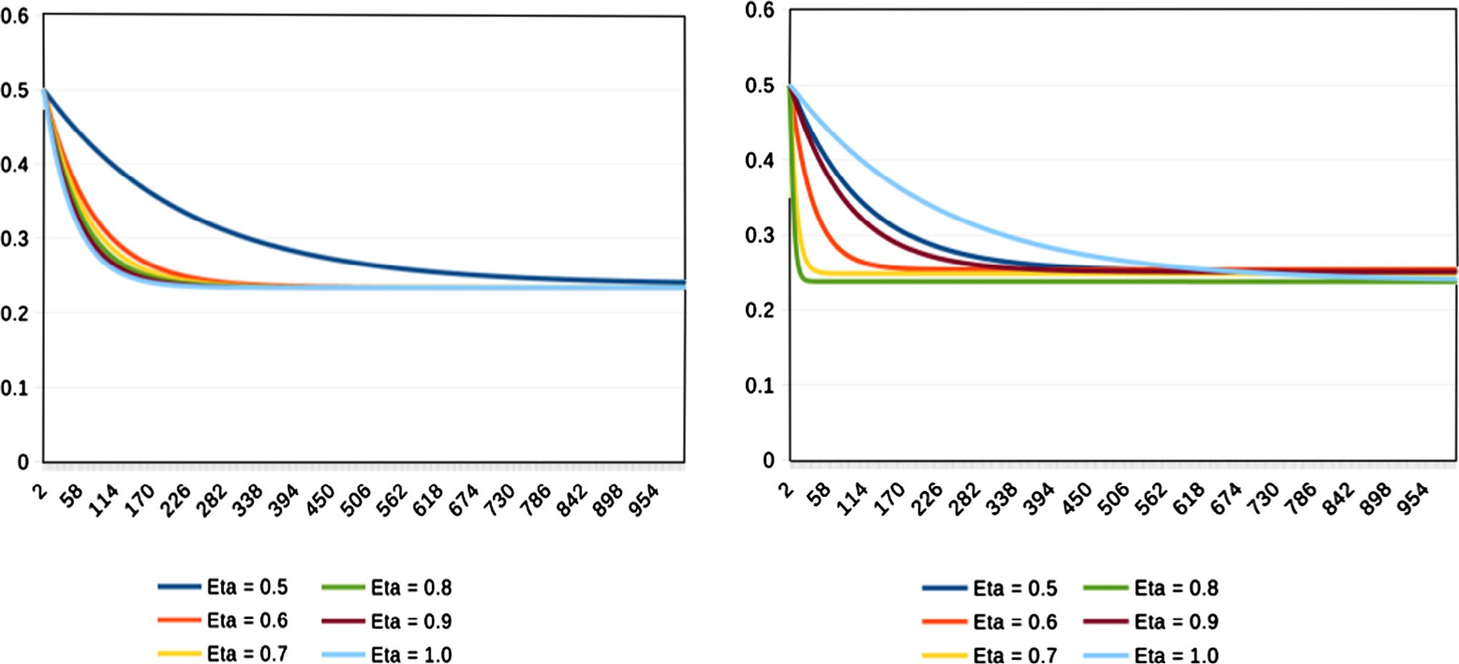

(A) Gaussian RBF

(b) Inverse multi-quadric RBF

Figure 8 Experiment 1 (A & E) MSE graph for gradient descent approach with varying g value.

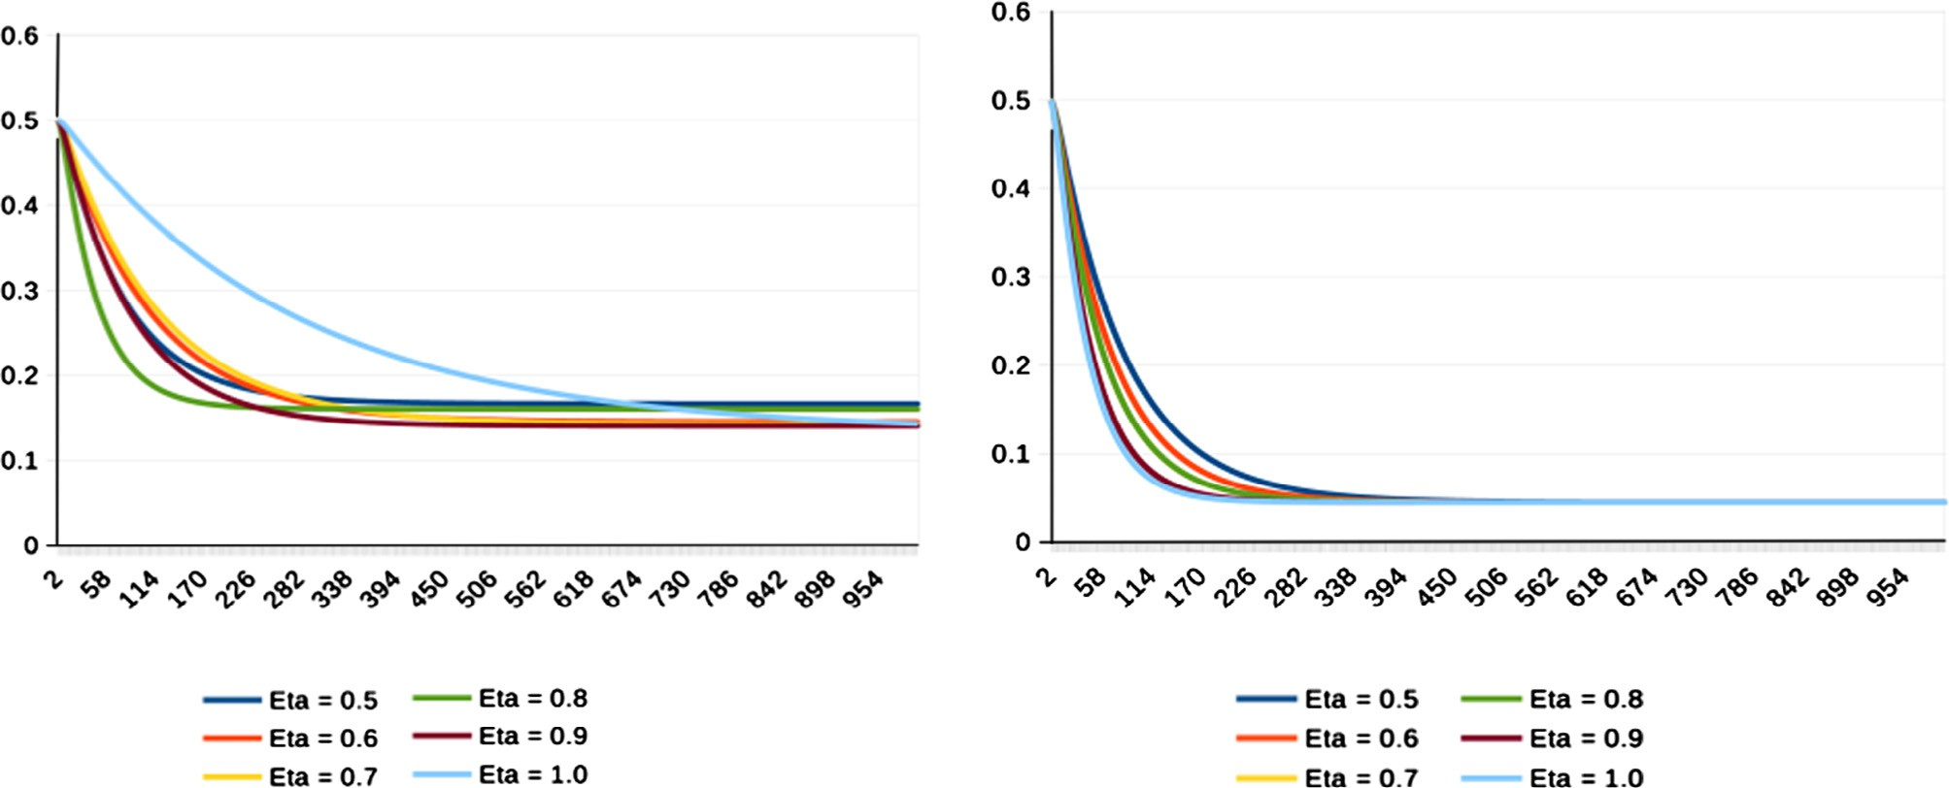

(a) GaussianRBF

(b) Inverse multi-quadric RBF

Figure 9 Experiment 2 (D & E) MSE graph for gradient descent approach with varying g value.

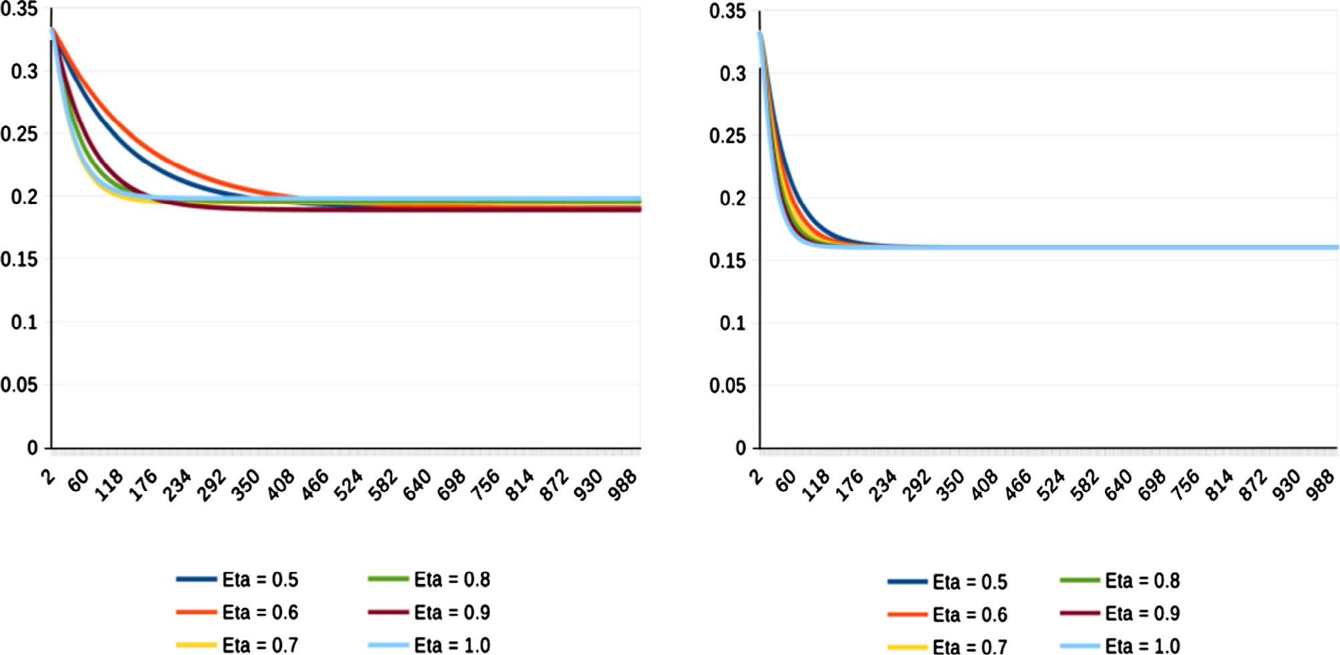

(a) Gaussian RBF

(b) Inverse multi-quadric RBF

Figure 10 Experiment 3 (A + D & E) MSE graph for gradient descent approach with varying g value.

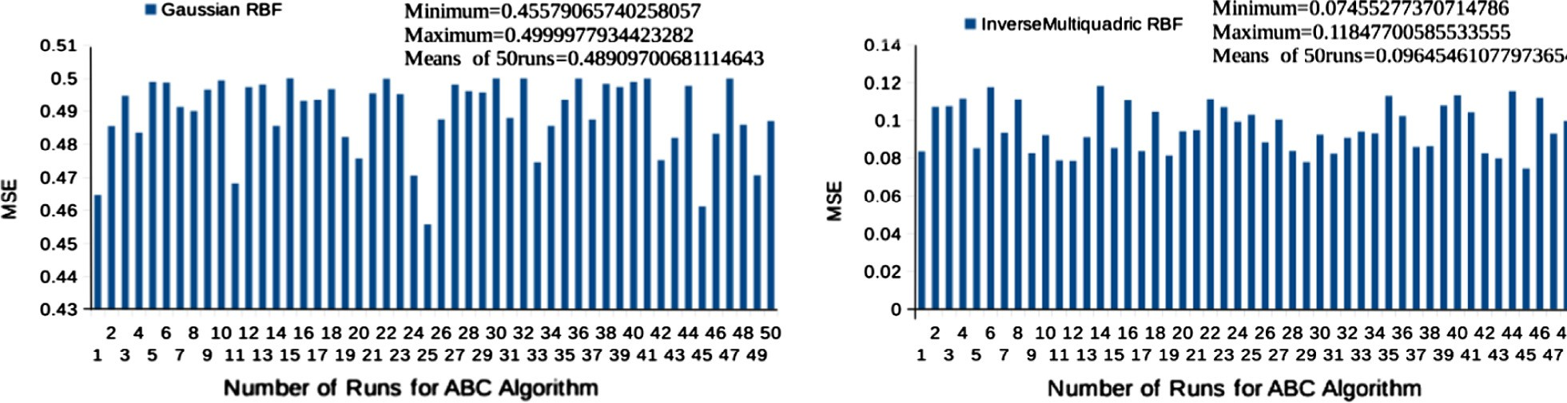

# (a) GaussianRBF (b) Inverse-multi-quadric RBF

Figure 11 Experiment 1 (set A & E) MSE graph for ABC trained RBF.

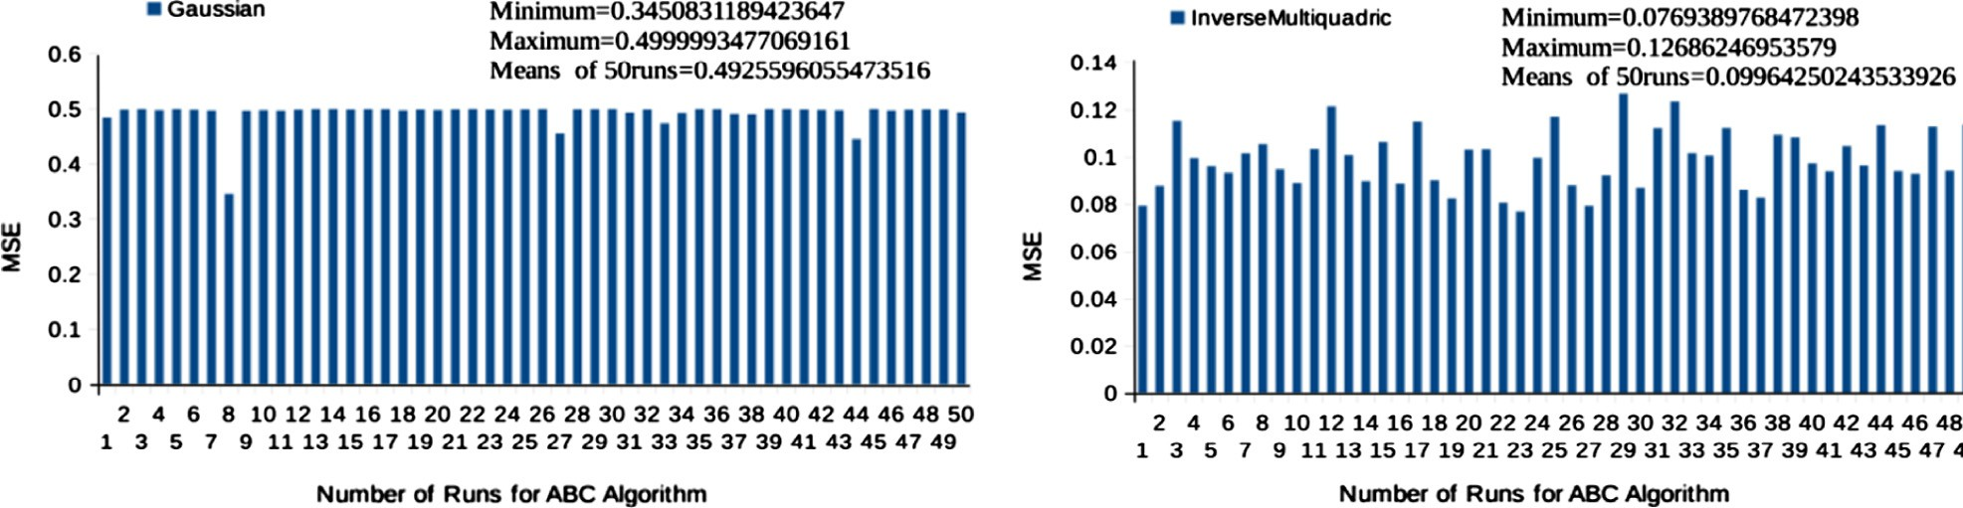

# (a) GaussianRBF (b) Inverse-multi-quadric RBF

Figure 12 Experiment 2 (set D & E) MSE graph for ABC trained RBFNNN.

* + 1. Number of parameters to optimize = 880 (number of

center parameters + number of spread parameters +

g. Fitness function, *f* (*c*;r;*w*)= 1 P*n d* — P*m w* * *H* (*x*2

number of weight parameters)

* + 1. *lb* = —1, *ub* = +1 (*lb-*lower bound and *ub*-upper bound for parameters)

where for Gaussian function *Hj*(*x*) is given in Eq. (4),

Multi-quadric function *Hj*(*x*) is given in Eq. (5) and Inverse multi-quadric function *Hj*(*x*) is given in Eq. (6).

*n*

*i*=1

*j*

*j*=1

*j*

*j*

)

,

|  |  |  |  |  |  |  |  |  |
| --- | --- | --- | --- | --- | --- | --- | --- | --- |
| Table 2 Performance Comparison between GD learning and ABC learning with Inverse-multi-quadric RBFNN. | | | | | | | | |
| Experiments | Specificity |  |  | Sensitivity |  |  | Accuracy |  |
|  | RBFNN with | RBFNN with |  | RBFNN with | RBFNN with |  | RBFNN with | RBFNN with |
|  | GD | ABC |  | GD | ABC |  | GD | ABC |
| Set A & E | 84.1 | 85.7 |  | 65.7 | 66.4 |  | 71.5 | 72.5 |
| Set D & E | 100.0 | 100.0 |  | 80.0 | 88.5 |  | 87.5 | 93.5 |
| Set A + D & E | 76.8 | 95.6 |  | 63.2 | 66.0 |  | 73.3 | 81.6 |
|  |  |  |  |  |  |  |  |  |

|  |  |  |  |  |  |  |  |  |
| --- | --- | --- | --- | --- | --- | --- | --- | --- |
| Table 3 Performance comparison between ABC learning and modified ABC learning with Inverse-multi-quadric RBFNN. | | | | | | | | |
| Experiments | Specificity |  |  | Sensitivity |  |  | Accuracy |  |
|  | RBFNN with ABC | RBFNN with MABC |  | RBFNN with ABC | RBFNN with MABC |  | RBFNN with ABC | RBFNN with MABC |
| Set A & E | 85.7 | 88.1 |  | 66.4 | 66.0 |  | 72.5 | 73.5 |
| Set D & E | 100.0 | 100.0 |  | 88.5 | 97.0 |  | 93.5 | 98.5 |
| Set A + D & E | 95.6 | 96.0 |  | 66.0 | 68.4 |  | 81.6 | 83.0 |
|  |  |  |  |  |  |  |  |  |

|  |  |  |  |  |  |  |  |  |
| --- | --- | --- | --- | --- | --- | --- | --- | --- |
| Table 4 Performance comparison between GD learning and ABC learning with Inverse-multi-quadric RBFNN with 10-fold cross validation. | | | | | | | | |
| Experiments | Average specificity |  |  | Average sensitivity |  |  | Average accuracy |  |
|  | RBFNN with | RBFNN with |  | RBFNN with | RBFNN with |  | RBFNN with | RBFNN with |
|  | GD | ABC |  | GD | ABC |  | GD | ABC |
| Set A & E | 84.0 | 84.2 |  | 65.2 | 65.2 |  | 71.0 | 71.5 |
| Set D & E | 100.0 | 100.0 |  | 79.5 | 87.5 |  | 86.0 | 92.5 |
| Set A + D & E | 75.2 | 93.4 |  | 62.0 | 65.5 |  | 71.4 | 80.5 |
|  |  |  |  |  |  |  |  |  |

|  |  |  |  |  |  |  |  |  |
| --- | --- | --- | --- | --- | --- | --- | --- | --- |
| Table 5 Performance comparison between ABC learning and modified ABC learning with Inverse-multi-quadric RBFNN with 10-fold cross validation. | | | | | | | | |
| Experiments | Average specificity |  |  | Average sensitivity |  |  | Average accuracy |  |
|  | RBFNN with | RBFNN with |  | RBFNN with | RBFNN with |  | RBFNN with | RBFNN with |
|  | ABC | MABC |  | ABC | MABC |  | ABC | MABC |
| Set A & E | 84.2 | 87.5 |  | 65.2 | 65.6 |  | 71.5 | 72.6 |
| Set D & E | 100.0 | 100.0 |  | 87.5 | 96.4 |  | 92.5 | 98.0 |
| Set A + D & E | 93.4 | 95.6 |  | 65.5 | 68.0 |  | 80.5 | 82.3 |
|  |  |  |  |  |  |  |  |  |

For RBFNN, there are mainly three types of basis func- tions that are used like, Gaussian, Multi-quadric and Inverse multi-quadric. But due to high performance of Gaussian and Inverse multi-quadric, the Multi-quadric function has been

*EE*

Specificity = *EE* + *AE*

*AA*

Sensitivity = *AA* + *EA*

, (14)

, and (15)

ignored.

Classification results of the classifiers were collected by a

The accuracy of the model is defined as

confusion matrix. In a confusion matrix, each cell contains

the number of exemplars classified for the corresponding

Accuracy = *AA* + *EE*

*EE* + *AA* + *EA* + *AE*

. (16)

combination of desired and actual network outputs. The test

performance of the methods was determined by the computa- tion of the following statistical parameters for different experiments.

Experiment 1 (set A and E):

where *AA*: the count of cases that belong to the *A* class and are predicted as *A* (true positives); *AE*: the count of cases that belong to the *E* class and are predicted as *A* (false positives); *EE*: the count of cases that belong to the *E* class and are pre- dicted as *E* (true negatives); and *EA*: the count of cases that

belong to the *A* class and are predicted as *E* (false negatives). Similarly, the meaning of *A* and *E* is defined as follows: *A*: EEG signals recorded from healthy volunteers with eyes open, *E*: EEG signals recorded from epilepsy patients during epilep- tic seizures.

Similarly, the performance metrics of other experiments have been defined like Eqs. (14)–(16). However, the notations are different. The results have been validated using *k*-fold cross validation. Here, *k* value is chosen as 10. So, the whole dataset is divided into 10 unique subsets i.e. in each cycle of classifica- tion process, one set is taken for testing purpose and rest of the sets are taken for training purpose. As a result, total 10 cycles of classification task have been performed and the perfor- mance metrics were computed. Thus, the average of these met- rics was taken as the final performance results. It was observed that there was a very minute difference between the best per- formance results and average performance results obtained through cross validation.

* 1. *Result and analysis*

Figs. 8–10 show the MSE graph for RBFNNN with (a) Gaus- sian RBF and (b) Inverse multi-quadric RBF with varying learning parameter for experiment numbers 1, 2 and 3 respec- tively. From these experiments it has been concluded that for Inverse multi-quadric RBF there is no effect of the learning parameter. For Gaussian RBF as the value of learning param- eter increases, the mean square error quickly tends to its min- ima and for certain value of learning parameter it gives minimum MSE.

Now, RBFNN has been trained using ABC algorithm and for performance evaluation the Mean Square Error graph has been plotted for different runs of ABC. Figs. 11 and 12 show the variation in MSE for 50 runs of ABC algorithm with (a) Gaussian RBF and (b) Inverse multi-quadric RBF. It is being clearly observed that using ABC training algorithm the perfor- mance of RBFNNN with Inverse multi-quadric function has been enhanced. The MSE has been successfully reduced to

0.07 (approximately), after training the network with ABC optimization algorithm.

Table 2 shows the comparison of *sensitivity*, *specificity*, and *accuracy* between two training approaches, Gradient descent and Artificial Bee Colony of RBFNN. Clearly, it shows that the performance of RBFNN trained with ABC algorithm is better than the traditional Gradient Descent approach in all three experiments. Table 3 shows the comparison of perfor- mance of general ABC and our modified ABC. These results were taken from the best performances of the classifiers. Tables 4 and 5 show the results taken from the 10-fold cross validated classifier. Evidently, there is not much of difference in these results. Though, there is some improvement in performance for experiments 1 and 3, we can find a huge improvement in experiment 3. From this experimental evaluation, it is clearly proved that modified ABC algorithm can classify EEG data for epilepsy identification with highest accuracy.

1. Conclusion

Our approach is primarily based on Artificial Bee Colony algo- rithm, which is a new and robust algorithm used for training

the RBFNN. However, we noticed that after adopting the bin- ary tournament selection in the onlooker bees phase our novel approach for classifying epileptic seizure vs. non-epileptic sei- zure in three distinct experiments was performing significantly better than GD and ABC trained RBFNN. The performance of ABC trained RBFNN algorithm is compared with Gradient Descent approach trained RBFNN which is mostly used by the researchers. Finally, our concluding remark says ABC can be applied successfully to enhance the performance of RBF network for classification of EEG signal for detecting epileptic seizures. Moreover, the pre-processing of EEG signal is done by using DWT which is also an important requirement before going for the classification task. Our future research will be on this subject to study the class imbalancement problem in the analysis of EGG signal.

References

1. [Niedermeyer E, da Silva F Lopes. Electroencephalography: basic](http://refhub.elsevier.com/S1110-8665(16)30015-9/h0005) [principles, clinical applications, and related fields. 5th ed. London:](http://refhub.elsevier.com/S1110-8665(16)30015-9/h0005) [Lippincott Williams and Wilkins; 2005](http://refhub.elsevier.com/S1110-8665(16)30015-9/h0005).
2. [Majumdar K. Human scalp EEG processing: various soft](http://refhub.elsevier.com/S1110-8665(16)30015-9/h0010) [computing approaches. Appl Soft Comput 2011;11(8):4433–47](http://refhub.elsevier.com/S1110-8665(16)30015-9/h0010).
3. [Sanei S, Chambers JA. EEG signal processing. New York: Wiley;](http://refhub.elsevier.com/S1110-8665(16)30015-9/h0015) [2007](http://refhub.elsevier.com/S1110-8665(16)30015-9/h0015).
4. [Lehnertz K. Non-linear time series analysis of intracranial EEG](http://refhub.elsevier.com/S1110-8665(16)30015-9/h0020) [recordings in patients with epilepsy – an overview. Int J](http://refhub.elsevier.com/S1110-8665(16)30015-9/h0020) [Psychophysiol 1999;34(1):45–52](http://refhub.elsevier.com/S1110-8665(16)30015-9/h0020).
5. [Alicata FM, Stefanini C, Elia M, Ferri R, Del Gracco S, Musumeci](http://refhub.elsevier.com/S1110-8665(16)30015-9/h0025) [SA. Chaotic behavior of EEG slow-wave activity during sleep.](http://refhub.elsevier.com/S1110-8665(16)30015-9/h0025) [Electroencephalogr Clin Neurophysiol 1996;99(6):539–43](http://refhub.elsevier.com/S1110-8665(16)30015-9/h0025).
6. [Ocak H. Automatic detection of epileptic seizures in EEG using](http://refhub.elsevier.com/S1110-8665(16)30015-9/h0030) [discrete wavelet transform and approximate entropy. Expert Syst](http://refhub.elsevier.com/S1110-8665(16)30015-9/h0030) [Appl 2009;36(2):2027–36](http://refhub.elsevier.com/S1110-8665(16)30015-9/h0030).
7. [Witte H, Iasemidis LD, Litt B. Special issue on epileptic seizure](http://refhub.elsevier.com/S1110-8665(16)30015-9/h0035) [prediction. IEEE Trans Biomed Eng 2003;50(5):537–8](http://refhub.elsevier.com/S1110-8665(16)30015-9/h0035).
8. [Acharya UR, Sree SV, Swapna G, Martis R Joy, Suri JS.](http://refhub.elsevier.com/S1110-8665(16)30015-9/h0040) [Automated EEG analysis of epilepsy: a review. Knowl Based Syst](http://refhub.elsevier.com/S1110-8665(16)30015-9/h0040) [2013;45:147–65](http://refhub.elsevier.com/S1110-8665(16)30015-9/h0040).
9. [Finley KH, Dynes JB. Electroencephalographic studies in](http://refhub.elsevier.com/S1110-8665(16)30015-9/h0045) [epilepsy: a critical analysis. Brain 1942;65:256–65](http://refhub.elsevier.com/S1110-8665(16)30015-9/h0045).
10. [Gotman J. Automatic recognition of epileptic seizure in the EEG.](http://refhub.elsevier.com/S1110-8665(16)30015-9/h0050) [Electroencephalogr Clin Neurophys 1982;54(5):530–40](http://refhub.elsevier.com/S1110-8665(16)30015-9/h0050).
11. [Elo P, Saarinen J, Varri A, Nieminen H, Kaski K. Classification](http://refhub.elsevier.com/S1110-8665(16)30015-9/h0055) [of epileptic EEG by using self-organizing maps. In: Aleksander I,](http://refhub.elsevier.com/S1110-8665(16)30015-9/h0055) [Taylor J, editors. Artificial neural networks, vol. 2. p. 1147–50](http://refhub.elsevier.com/S1110-8665(16)30015-9/h0055).
12. [Gabor AJ, Seyal M. Automated interictal EEG spike detection](http://refhub.elsevier.com/S1110-8665(16)30015-9/h0060) [using artificial neural networks. Electroencephalogr Clin Neuro-](http://refhub.elsevier.com/S1110-8665(16)30015-9/h0060) [physiol 1992;83(5):271–80](http://refhub.elsevier.com/S1110-8665(16)30015-9/h0060).
13. [Jando G, Siegel RM, Horvath Z, Buzsaki G. Pattern recognition](http://refhub.elsevier.com/S1110-8665(16)30015-9/h0065) [of the electroencephalogram by artificial neural networks. Elec-](http://refhub.elsevier.com/S1110-8665(16)30015-9/h0065) [troencephalogr Clin Neurophysiol 1993;86(2):100–9](http://refhub.elsevier.com/S1110-8665(16)30015-9/h0065).
14. [Webber WRS, Litt B, Wilson K, Lesser RP. Practical detection of](http://refhub.elsevier.com/S1110-8665(16)30015-9/h0070) [epileptiform discharges (Eds) in the EEG using an artificial neural](http://refhub.elsevier.com/S1110-8665(16)30015-9/h0070) [network: a comparison of raw and parameterized EEG data.](http://refhub.elsevier.com/S1110-8665(16)30015-9/h0070) [Electroencephalogr Clin Neurophysiol 1994;91(3):194–204](http://refhub.elsevier.com/S1110-8665(16)30015-9/h0070).
15. [Pradhan N, Sadasivan PK, Arunodaya GR. Detection of seizure](http://refhub.elsevier.com/S1110-8665(16)30015-9/h0075) [activity in EEG by an artificial neural network: a preliminary](http://refhub.elsevier.com/S1110-8665(16)30015-9/h0075) [study. Comput Biomed Res 1996;29(4):303–13](http://refhub.elsevier.com/S1110-8665(16)30015-9/h0075).
16. [Varsta M, Heikkonen J, Del J, Millan R. Epileptic activity](http://refhub.elsevier.com/S1110-8665(16)30015-9/h0080) [detection in EEG with neural networks. In: Proc of 3rd int conf](http://refhub.elsevier.com/S1110-8665(16)30015-9/h0080) [eng applications of neural networks. p. 179–86](http://refhub.elsevier.com/S1110-8665(16)30015-9/h0080).
17. [Gabor AJ. Seizure detection using a self-organizing neural](http://refhub.elsevier.com/S1110-8665(16)30015-9/h0085) [network: validation and comparison with other detection strate-](http://refhub.elsevier.com/S1110-8665(16)30015-9/h0085) [gies. Electroencephalogr Clin Neurophysiol 1998;107(1):27–32](http://refhub.elsevier.com/S1110-8665(16)30015-9/h0085).
18. [Walczack S, Nowack WJ. An artificial neural network approach](http://refhub.elsevier.com/S1110-8665(16)30015-9/h0090) [to diagnosing epilepsy using lateralized bursts of theta EEGs. J](http://refhub.elsevier.com/S1110-8665(16)30015-9/h0090) [Med Syst 2001;25(1):9–20](http://refhub.elsevier.com/S1110-8665(16)30015-9/h0090).
19. [Nigam VP, Graupe D. A neural-network-based detection of](http://refhub.elsevier.com/S1110-8665(16)30015-9/h0095) [epilepsy. Neurol Res 2004;26(1):55–60](http://refhub.elsevier.com/S1110-8665(16)30015-9/h0095).
20. [Mishra BSP, Dehuri S, Wang GN. A state-of-the-art review of](http://refhub.elsevier.com/S1110-8665(16)30015-9/h0100) [artificial bee colony in the optimization of single and multiple](http://refhub.elsevier.com/S1110-8665(16)30015-9/h0100) [criteria. Int J Appl Metaheurist Comput 2013;4(1):32–49](http://refhub.elsevier.com/S1110-8665(16)30015-9/h0100).
21. [Satapathy SK, Jagadev AK, Dehuri S. An empirical analysis of](http://refhub.elsevier.com/S1110-8665(16)30015-9/h0105) [training algorithms of neural networks: a case study of EEG](http://refhub.elsevier.com/S1110-8665(16)30015-9/h0105) [signal classification using java framework. Adv Intell Syst](http://refhub.elsevier.com/S1110-8665(16)30015-9/h0105) [Comput 2015;309:151–60](http://refhub.elsevier.com/S1110-8665(16)30015-9/h0105).
22. [Robert C, Gaudy JF, Limoge A. Electroencephalogram processing](http://refhub.elsevier.com/S1110-8665(16)30015-9/h0110) [using neural networks. Clin Neurophysiol 2000;113(5):694–701](http://refhub.elsevier.com/S1110-8665(16)30015-9/h0110).
23. [Aslan K, Bozdemir H, Sahin C, Ogulata SN, Erol R. A radial](http://refhub.elsevier.com/S1110-8665(16)30015-9/h0115) [basis function neural network model for classification of epilepsy](http://refhub.elsevier.com/S1110-8665(16)30015-9/h0115) [using EEG signals. J Med Syst 2008;32(5):403–8](http://refhub.elsevier.com/S1110-8665(16)30015-9/h0115).
24. [Dehuri S, Roy R, Cho SB, Ghosh A. An improved swarm](http://refhub.elsevier.com/S1110-8665(16)30015-9/h0120) [optimized functional link artificial neural network (ISO-FLANN)](http://refhub.elsevier.com/S1110-8665(16)30015-9/h0120) [for classification. J Syst Softw 2012;85(6):1333–45](http://refhub.elsevier.com/S1110-8665(16)30015-9/h0120).
25. [Dash ChSK, Dash AP, Dehuri S, Cho SB, Wang GN.](http://refhub.elsevier.com/S1110-8665(16)30015-9/h0125) [DE+RBFNNs based classification: a special attention to](http://refhub.elsevier.com/S1110-8665(16)30015-9/h0125) [removal of inconsistency and irrelevant features. Eng Appl AI](http://refhub.elsevier.com/S1110-8665(16)30015-9/h0125) [2013;26(10):2315–26](http://refhub.elsevier.com/S1110-8665(16)30015-9/h0125).
26. [Dehuri S, Cho SB. Evolutionary optimized features in func-](http://refhub.elsevier.com/S1110-8665(16)30015-9/h0130) [tional link neural network for classification. Expert Syst Appl](http://refhub.elsevier.com/S1110-8665(16)30015-9/h0130) [2010;37(6):4379–91](http://refhub.elsevier.com/S1110-8665(16)30015-9/h0130).
27. [Andrzejak RG, Lehnertz K, Rieke C, Mormann F, David P, Elger](http://refhub.elsevier.com/S1110-8665(16)30015-9/h0135) [CE. Indications of nonlinear deterministic and finite dimensional](http://refhub.elsevier.com/S1110-8665(16)30015-9/h0135) [structures in time series of brain electrical activity: dependence on](http://refhub.elsevier.com/S1110-8665(16)30015-9/h0135) [recording region and brain state. Phys Rev Lett 2001;64:061907-](http://refhub.elsevier.com/S1110-8665(16)30015-9/h0135) [1–7-8](http://refhub.elsevier.com/S1110-8665(16)30015-9/h0135).